**SPH3U 4.3 Solving Friction Problems**

1. **Static friction acting on several objects**

Two sleds are tied together with a rope. The coefficient of static friction between each sled and the snow is 0.22. A small child is sitting on sled 1 (total mass of 27 kg) and a larger child sits on sled 2 (total mass of 38 kg). An adult pulls on the sleds.

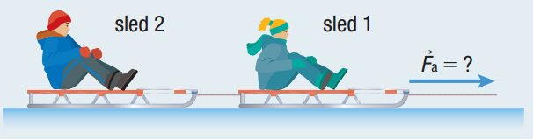

1. What is the greatest horizontal force that the adult can exert on sled 1 without moving either sled?
2. Calculate the magnitude of the tension in the rope between sleds 1 and 2 when the adult exerts this greatest horizontal force.
3. **Static friction can cause motion**

The coefficient of static friction between a person’s shoe and the ground is 0.70. Determine the maximum magnitude of acceleration of the 62 kg person, if he starts running on a horizontal surface from rest.

1. **Stopping a sliding box**

A 250 kg box slides down a ramp and then across a level floor. The coefficient of kinetic friction along the floor is 0.20. A person sees the box moving at 1.0 m/s [left] and pushes on it with a horizontal force of 140 N [right].

1. How far does the box travel before coming to rest?
2. How will the results change if the box is moving right and the person still pushes right with the same force?
3. **Kinetic friction and tension**

Two sleds tied together are pulled across an icy surface with an applied force of 150 N [E]. The mass of sled 1 is 18.0 kg and the mass of sled 2 is 12.0 kg. The coefficient of kinetic friction for each sled is 0.20.

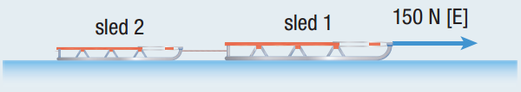

1. Calculate the acceleration of the sleds.
2. Determine the magnitude of the tension in the rope between the sleds.

**Homework:** page 178: #1, 3, 7, 8